FR77M Women's long sleeve original rugby shirt
- Semi-fitted shape
- Taped shoulders and side vents
- Twin-needle stitching on hems

- Semi-fitted, traditional collar, Elastane reinforced cuffs, side vents, twin-needle hems, taped shoulders. Rugby leisurewear garments are for leisure use only.
Washing Instructions
40 cotton. Do not bleach. Low temp 2 dot iron. P dry clean. Wash at 40 degrees. Wash dark colours separately. Re-shape while damp. Do not leave folded when damp. Iron on reverse. Wash and dry inside out. Dry out of Direct Heat and Sunlight.
Fabric
100% Ringspun cotton
Weight
300gsm
Size
XS 8 S 10 M 12 L 14 XL 16

- 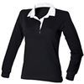
Black
- 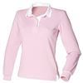
Dusky Pink
- 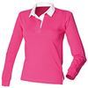
Fuchsia
- 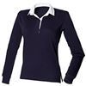
Navy

