J883F Women's full-zip fitted microfleece
- Cadet collar with zip protector
- Zipped side pockets
- Side vents, panelled construction
Fabric
100% Polyester anti-pill microfleece
Weight
190gsm
Size
XS 8 S 10 M 12 L 14 XL 16

Fine yarns create high quality density fabric, providing warmth without bulk and a great surface for decoration. Cadet collar with zip proctector. Zipped side pockets. Side vents and panelled construction for comfortable fit. Locker patch.
Washing Instructions
Suitable for 40C wash and tumble dry
- 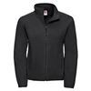
Black
- 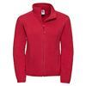
Classic Red
- 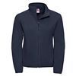
French Navy

