8700M Full-zip outdoor fleece
- Cadet collar
- Side pockets with reversed zips
- Cord pulls on all zips
Fabric
100% Polyester anti-pill fleece
Weight
320gsm
Size
XS 34/36" S 36/38" M 38/40" L 40/42" XL 42/44" 2XL 44/46" 3XL46/48" 4XL 48/50"

The compact fleece material, the smooth surface and the panelled construction allow for excellent fit and a more modern look. Cadet collar. Side pockets with reversed zips and inner mesh lining. Cord pulls on all zips. Bungee cord in hem.
Washing Instructions
Suitable for 40C wash and tumble dry
- 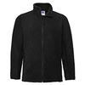
Black
- 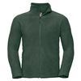
Bottle Green
- 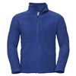
Bright Royal
- 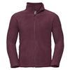
Burgundy
- 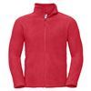
Classic Red
- 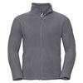
Convoy Grey
- 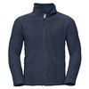
French Navy

