BC447 Thinsulate™ beanie
- Thinsulate™ lining
- Double layer knit
- Cuffed for optimal decoration
Fabric
100% Soft-touch acrylic
Weight
75g
Size
One size

Thinsulate™ lining. Non-ribbed turn up for easy decoration. Double layer knit.
Washing Instructions
Machine wash warm. Iron on low heat
- 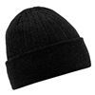
Black
- 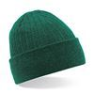
Bottle Green
- 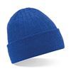
Bright Royal
- 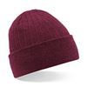
Burgundy
- 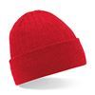
Classic Red
- 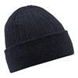
Dark Graphite
- 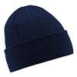
French Navy
- 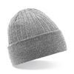
Heather Grey

