As well as the traditional senate pins, the following items are also available with options for personalisation and the Senate logo, the prices below include the Senate logo with a choice of wording and personalisation of name and number is extra.

Women’s Striped Blouse £30 (BR104) | Long Sleeved Shirt £29.50 (M=BA702)  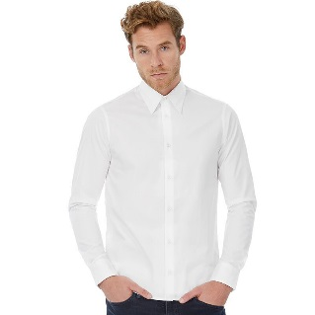 | Fleece Gilet £24.50  (M=8720M) (W=8720F) | Polo Shirt £17.50  (M=HB100) (W=HB121)  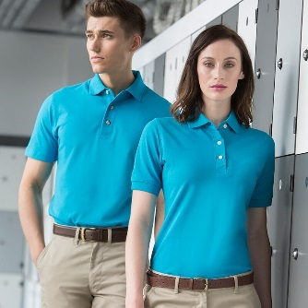
Apron £11.50 (WM364)  LOGO ONLY  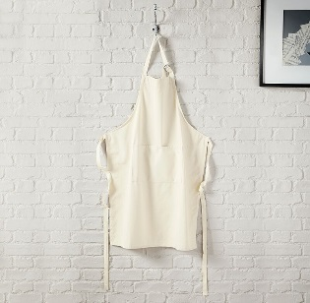 | Long Sleeved Blouse £27.50 (W=B712F) | Beanie £8.50 (BC447)  LOGO ONLY  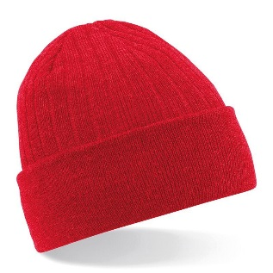 | Microfleece £28.50 (M=J880M) W=J883F)
Mens Short Sleeve Shirt £27.50 (BA713)  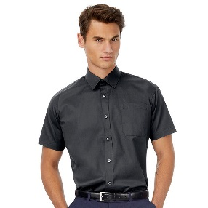 | Men’s Rugby Shirt £27.50 (FR01M)  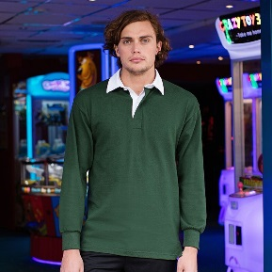 | Women’s Rugby Shirt £26.50 (FR77M) | Fleece £28  (M=8700M) (F=8700F)

Sizes and Colours

Women’s Striped Blouse (BR104) 8/10/12/14/16/18/20
Blue/white stripe, Pink/grey, White/grey

Men’s Long Sleeved Shirt (BA702) S/M/L/XL/2XL
Black, Deep Red, Navy, White

Women’s Long Sleeved Blouse (BA712F) 8/10/12/14/16/18-20/20-22/22-24
Black, Dark Grey, Deep Red, Navy, White

Ladies Poplin Shirt (PR300) From size 6 to a size 30 available
See website 30 colours available

Men’s Fleece (M=8700M) XS/S/M/L/XL/2XL/3XL/4XL
Black, Bottle Green, Bright Royal, Burgundy

Women’s Fleece (W=8700F) XS 8/S 10 /M 12 /L 14/XL 16/2XL 18
Black, Bottle Green, Bright Royal, Burgundy

Men’s Polo Shirt (HB100) XS 34”, S 36”, M 38/40”, L 42”, XL 44/46”, 2XL 48”
See website 29 colours available

Women’s Polo Shirt (HB121) S 10, M 12, L 14, XL 16, 2XL 18
See website 11 colours available

Men’s Short Sleeve Shirt (BA713) S 14.5/15”, M 15.5”, L 16/16.5”, XL 17/17.5” 2XL 18” (more sizes available)
Black, Dark Grey, Deep Red, Navy, White

Men’s Rugby Shirt (FR01M) S 36/38”, M 38/40”, L 42”, XL 44/46”, 2XL 48”
Black, Bottle Green, Burgundy, Chocolate, Navy, Olive Green, Purple, Red, Royal Blue, Slate Grey

Women’s Rugby (FR77M) XS 8, S 10, M 12, L 14, XL 16
Black, Dusky Pink, Fuchsia, Navy

Men’s Full Zip Micro Fleece (J880M) XS 34/36 S 36/38 M 38/40 L 40/42"XL 42/44 2XL 44/46 Black, Classic Red, French Navy

Women’s Full Zip Micro Fleece (J883F) XS 8, S 10, M 12, L 14, XL 16
Black, Classic Red, French Navy

Women’s Fleece Gilet (8720F) 8/10/12/14/16/18
Black, Bottle Green, Bright Royal, Burgundy, Classic Red, Convoy Red, Grey, French Navy

Men’s Fleece Gilet (8720M) XS/S/M/L/XL/2XL
Black, Bottle Green, Bright Royal, Burgundy, Classic Red, Convoy Red, Grey, French Navy

Beanie (BC447) LOGO ONLY One Size
Black, Bottle Green, Bright Royal, Burgundy, Classic Red, Dark Graphite, French Navy, Heather Grey
Craft Apron (WM364) LOGO ONLY 72 x 93 cm 100% cotton

Full details can be viewed on the British Senate website https://britishsenate.org.uk/merchandise or contact Veronica Robinson #63298 merchandise@britishsenate.org.uk

Order Form (logo is included in the price)
Item | Code | Colour | Size | Quantity | Price per item | Total  £
Personalisation £2.50 per item |  |  |  |  | £2.50
Postage £5 per item |  |  |  |  | £5.00
Total

Personalisation details (print exactly in capitals)
Name ……………………………………………….. Senate Number ………………………………………………
Circle as applicable which one you would like: BRITISH SENATE or JCI SENATE or SCOTTISH SENATE (included in the price)
Contact Details
Name ……………………………………………….. Senate Number ………………………………………………..
Delivery Address (or you can request collection at a Senate event)
………………………………………………………………………………………………………………………………..
……………………………………………………………………………………………………………………………..…
Postcode …………………………….. Contact Number……………………………………………………………......
Email address ……………………………………………………………………………………………………………...

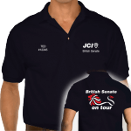 | Please note “BRITISH SENATE ON TOUR” items are ordered through Philip Cavalier-Lumley #70882 by emailing him at  philip@cavalier-lumley.co.uk

